**AZ Functions Assignment**

**Karan Kumar**

**Using VSCode :**

:1: Go to extensions and install the azure functions and sign in to the azure through VSCode.

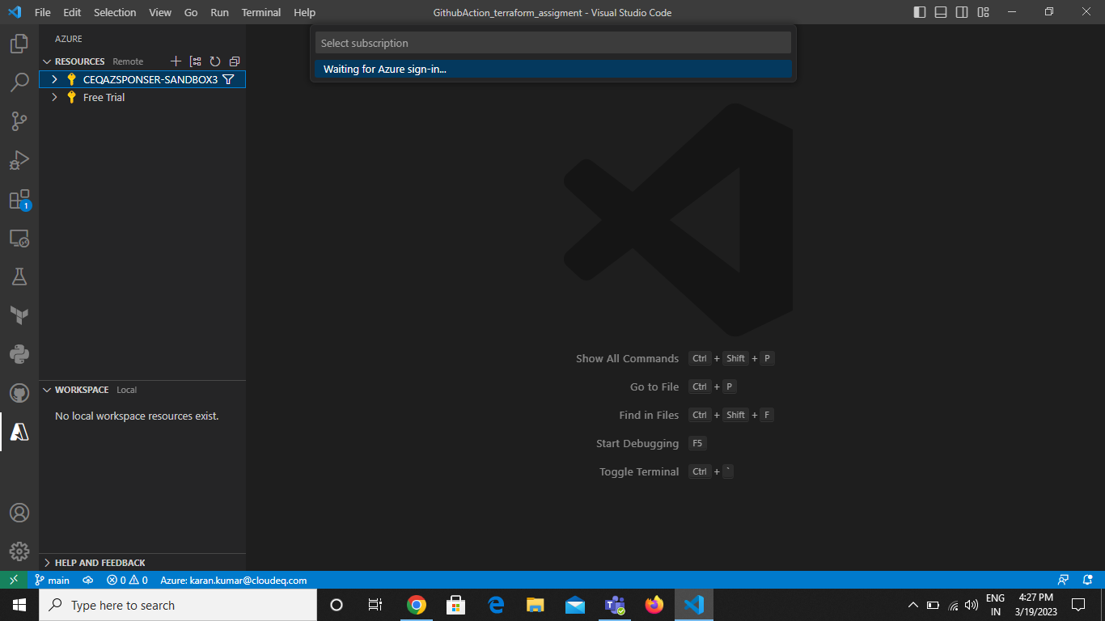

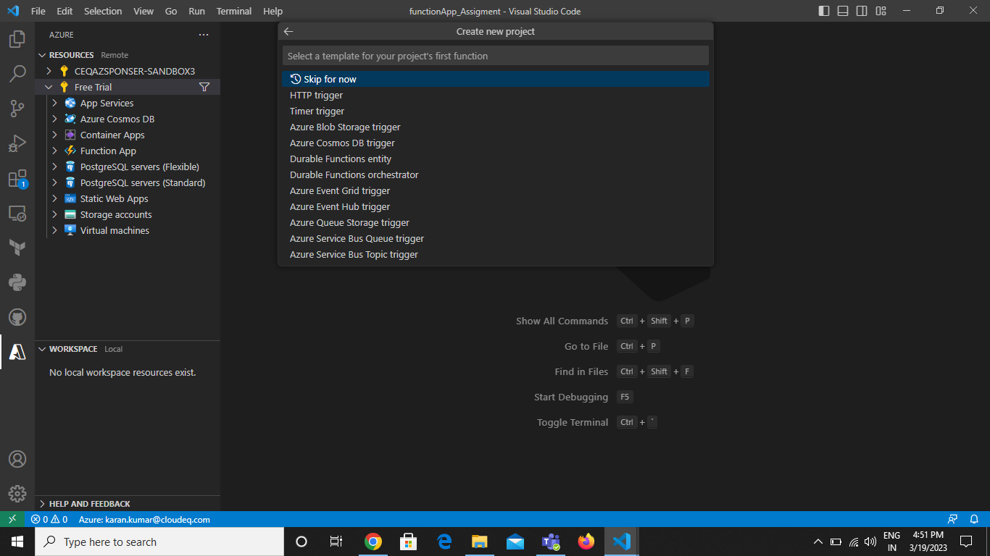

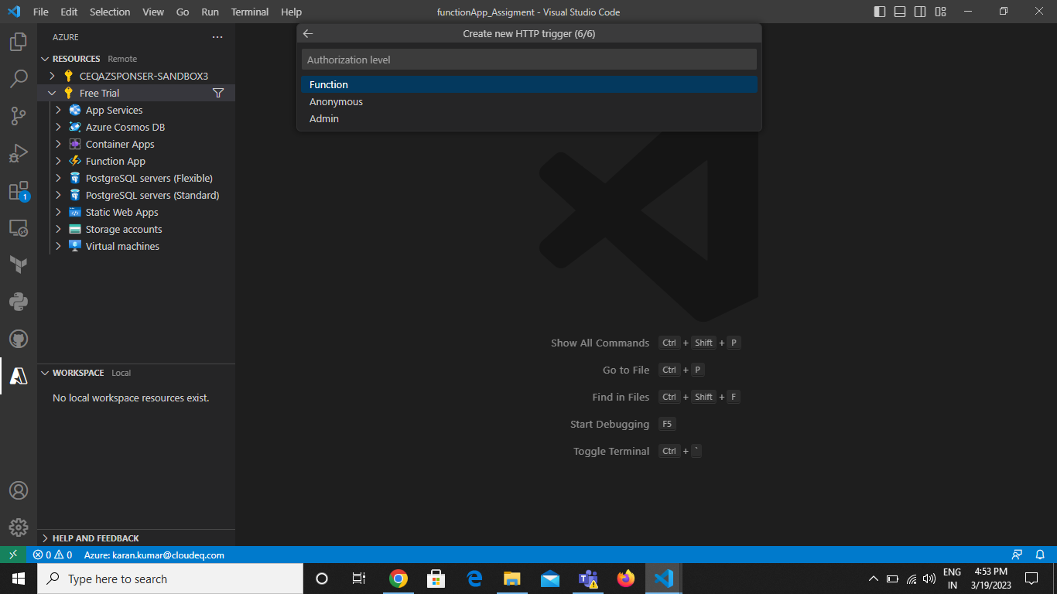

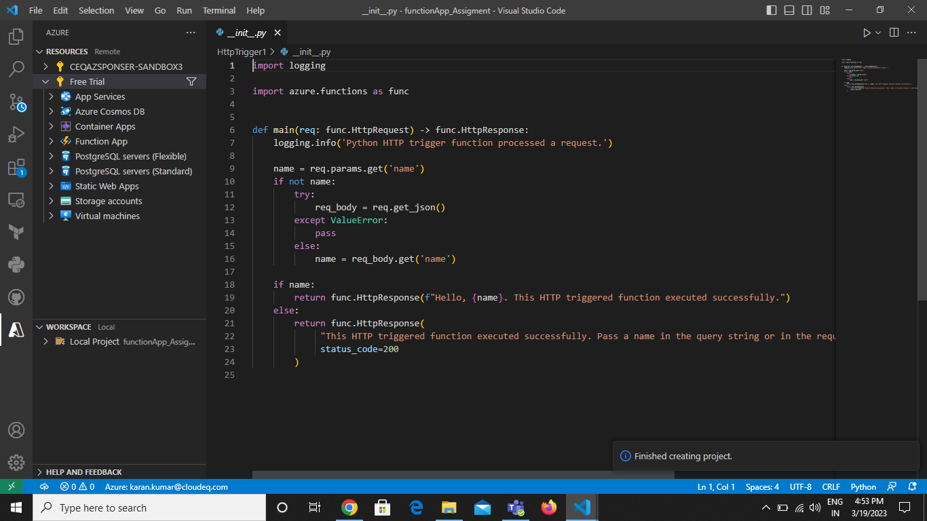

And enter the necessary details and the function is created.

First create the function app. And then deploy the function in app.

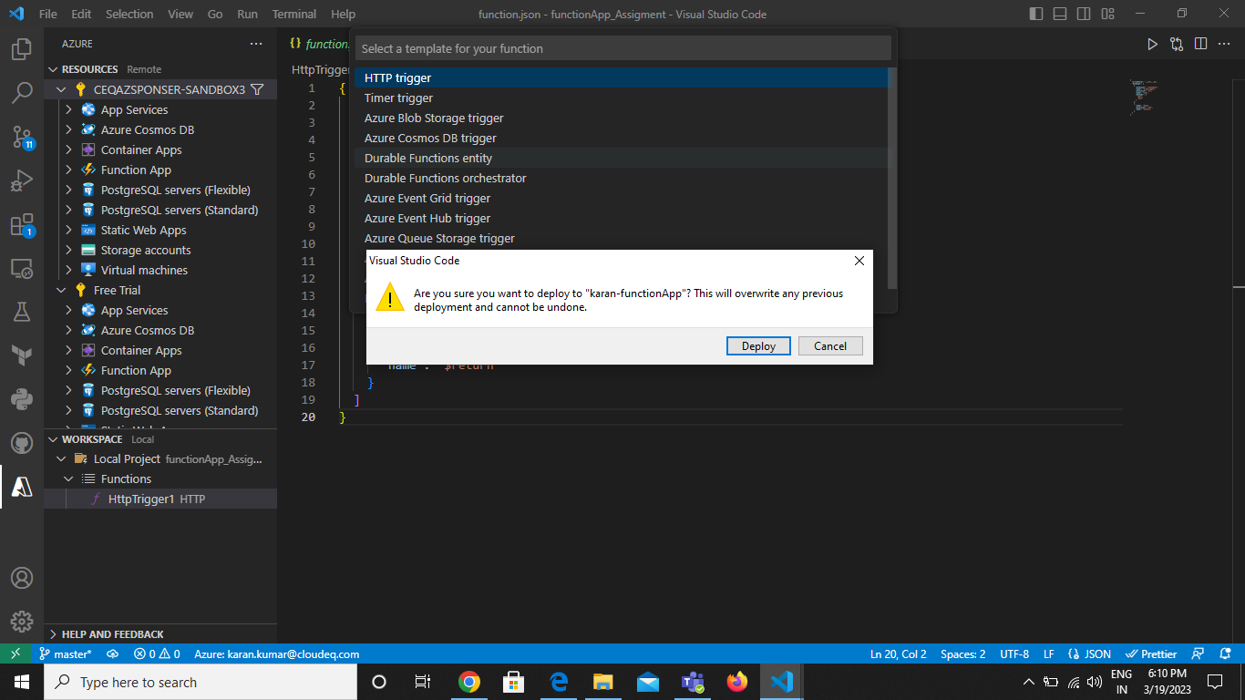

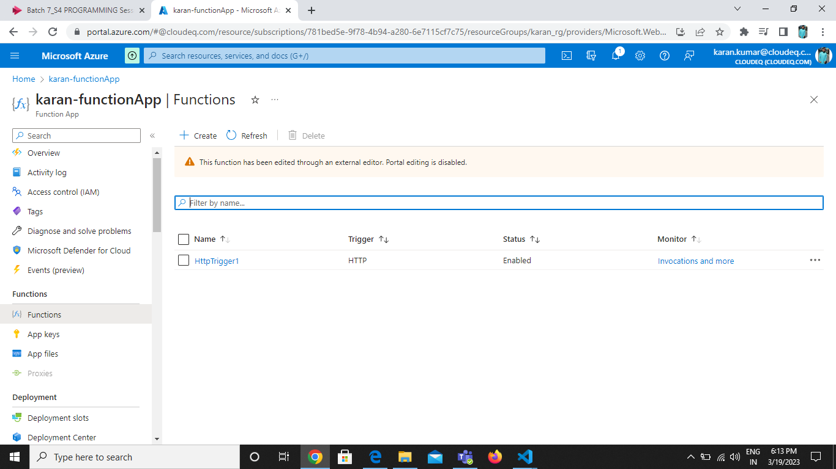

The function app is created and when the url is hit the trigger invoke and logs are created.

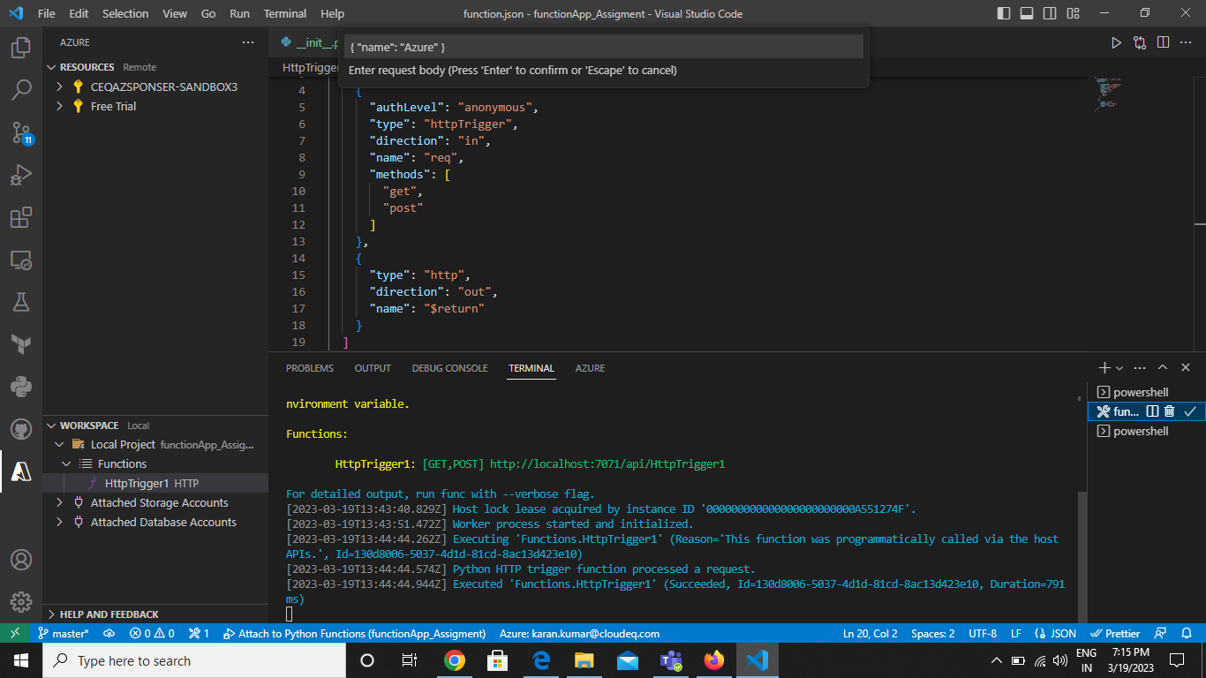

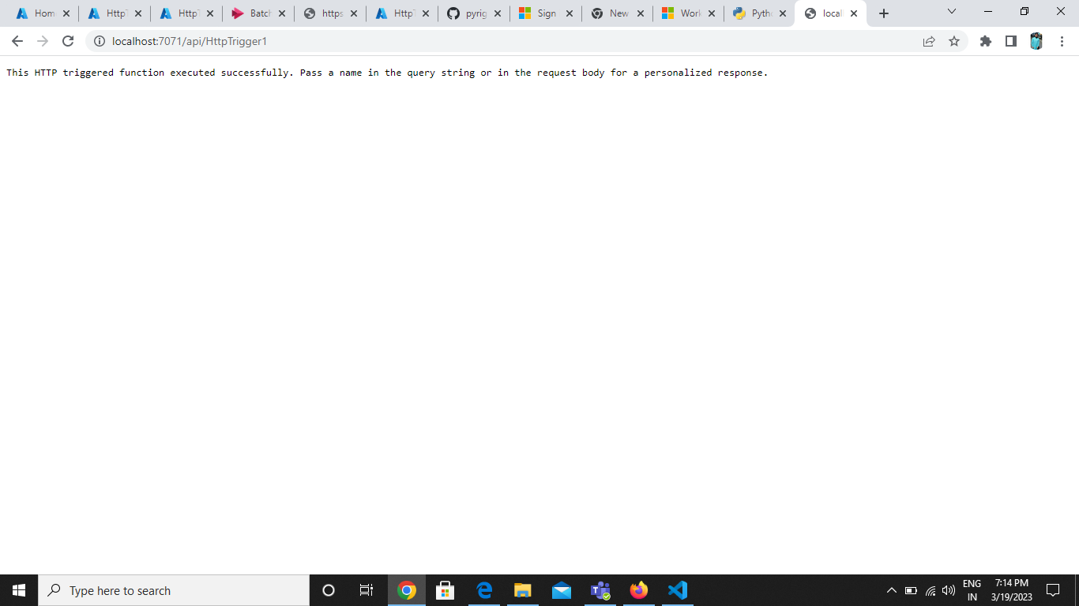

**Timer Trigger:**

Timer trigger uses the cron expression to trigger the function. Here we give the time at which the function should be triggered .We can create it using two ways using portal and using vscode. The steps to create it using vscode is done below:

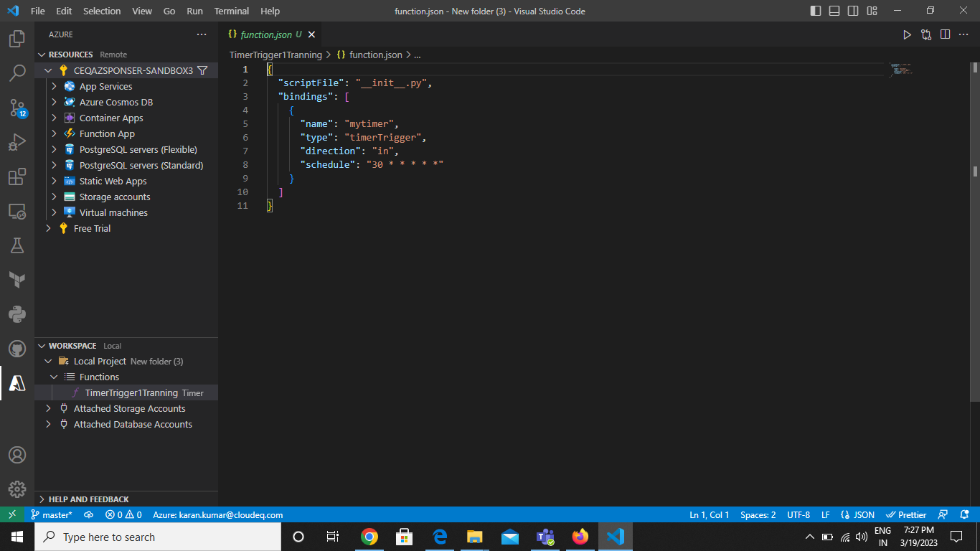

First create the trigger in the workspace by going through process.

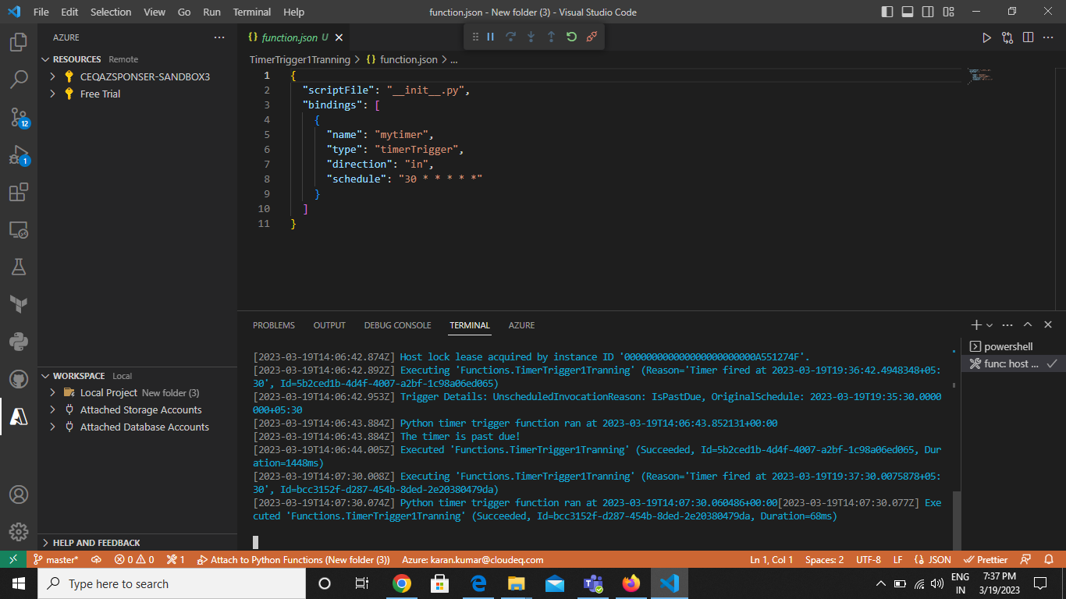

Now deploy the Function:

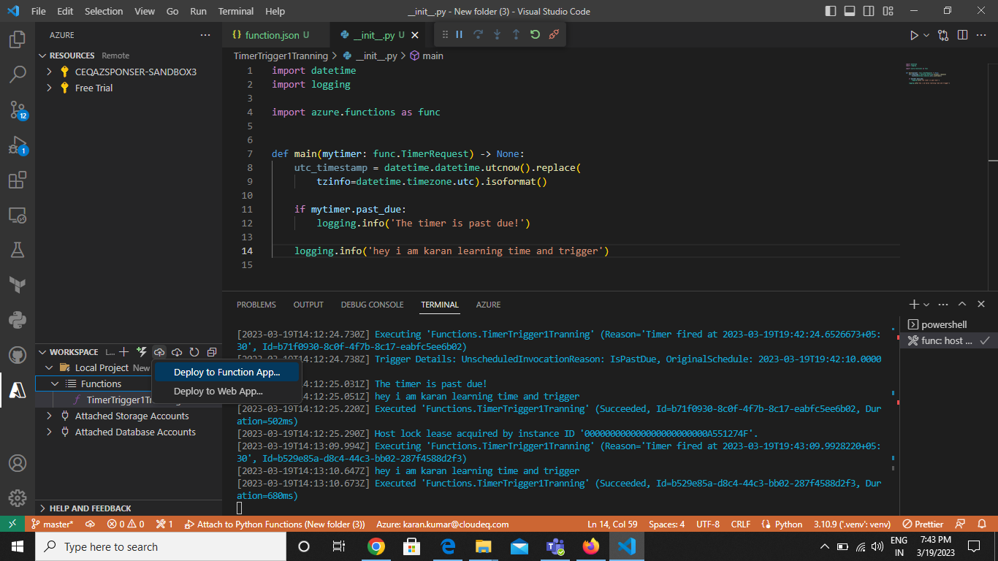

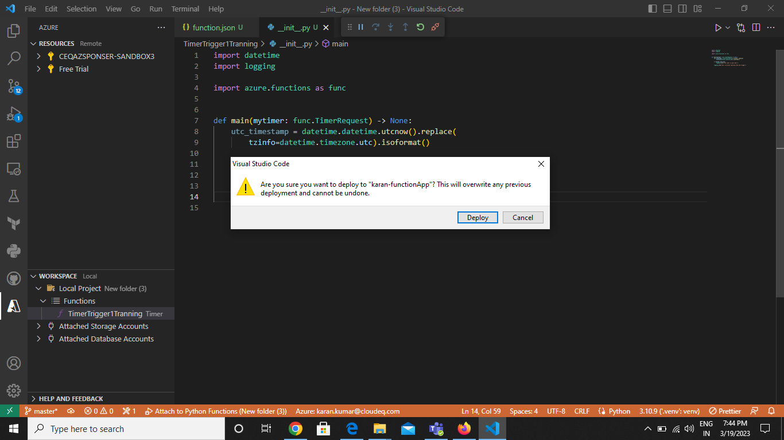

The timer trigger is added.

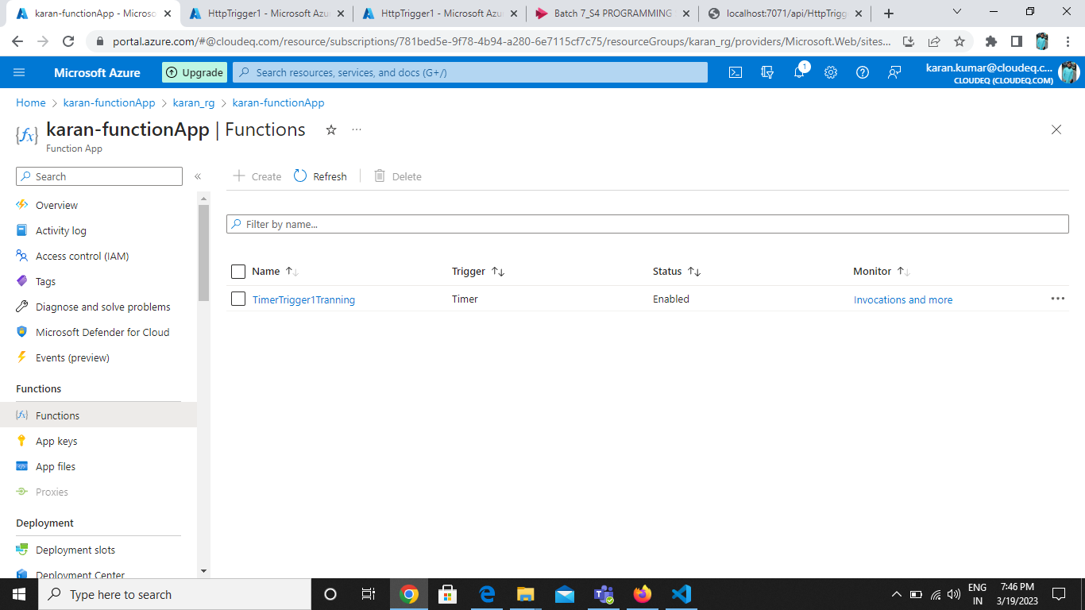

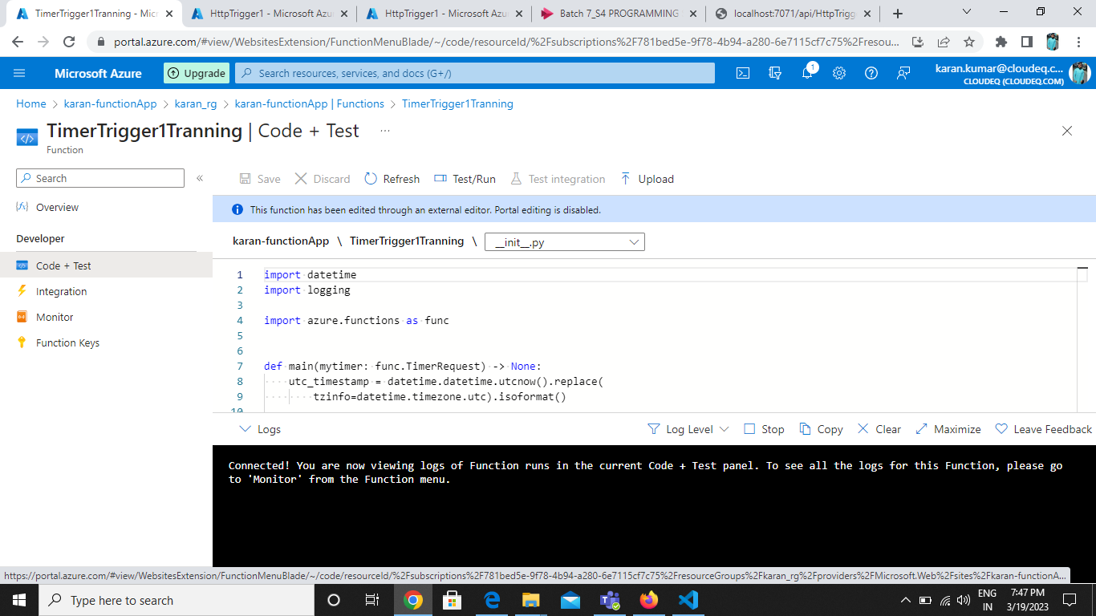

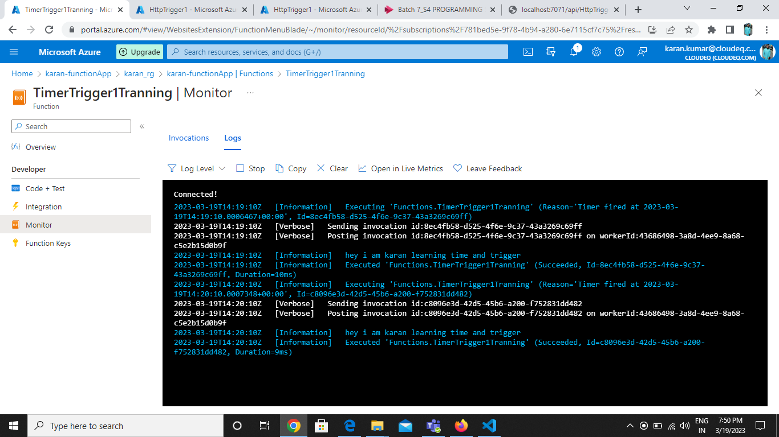

After every 10 sec the function is triggered as we can see in the logs.

**Queue Trigger :**

:This function is creted in the function app and is trigger when the message is added in the queue. To make this trigger we can do following steps:

First create the function app:

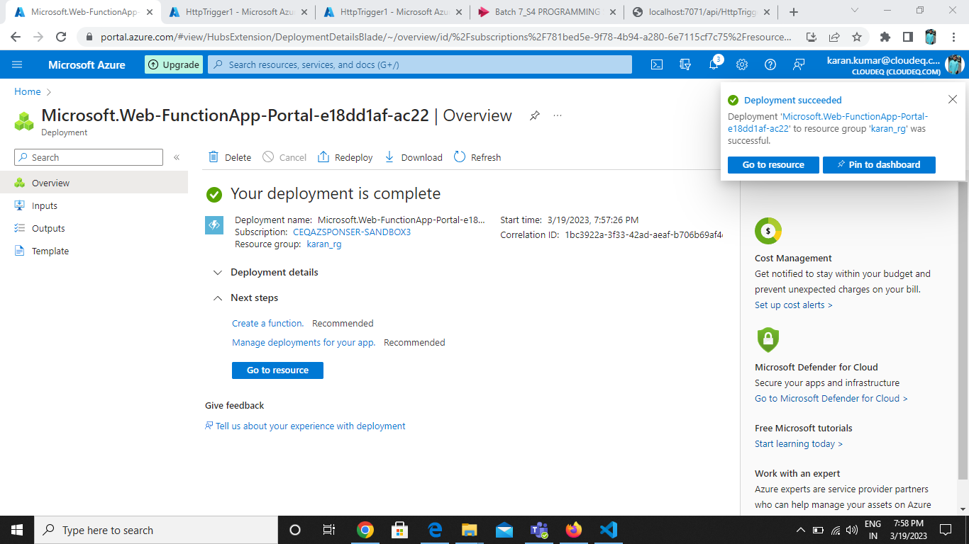

Create Function and add Add Queue Storage Trigger:

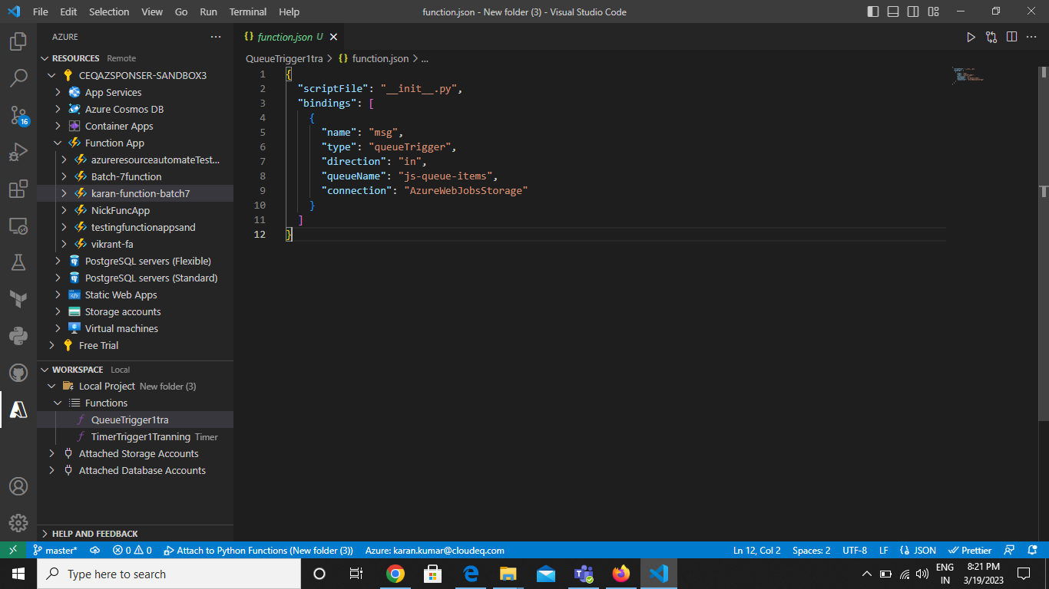

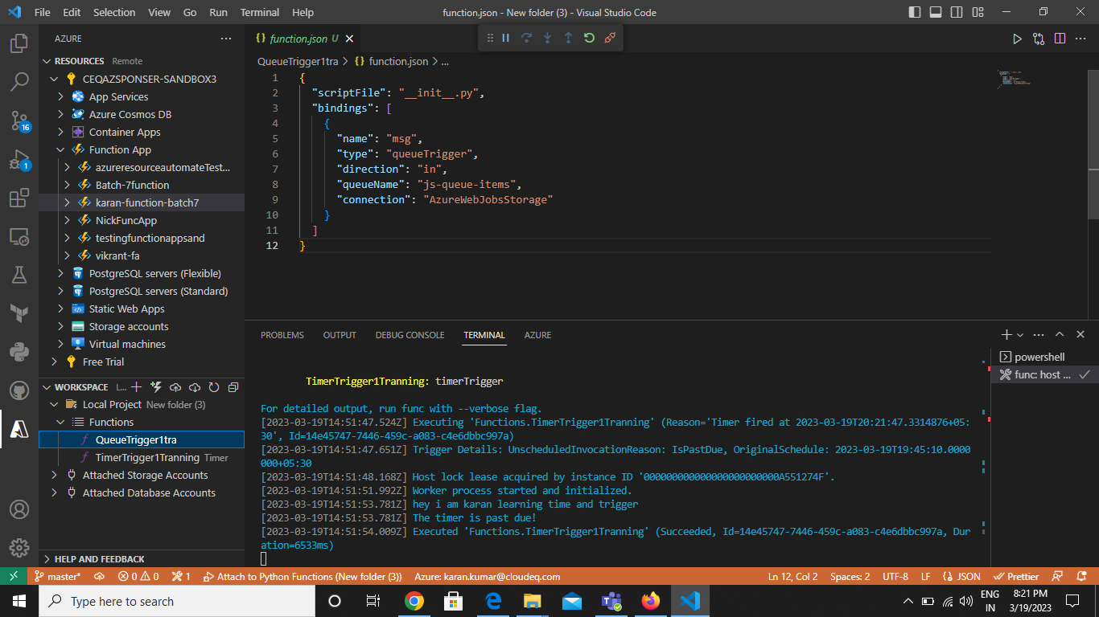

Deploy The Queue Trigger:

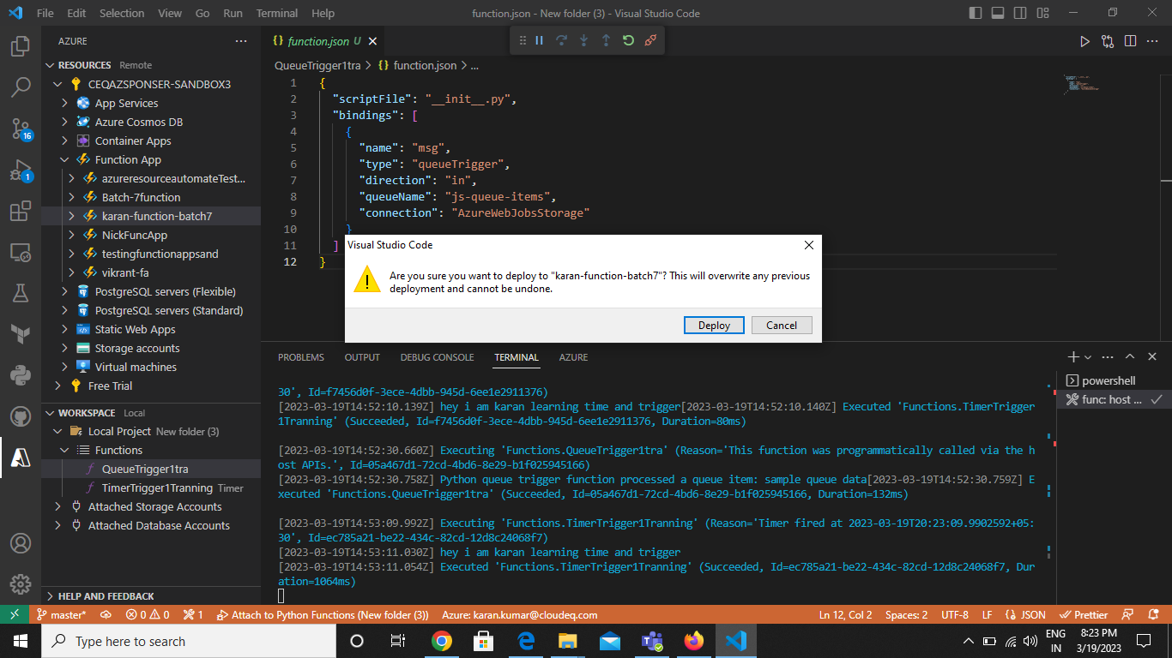

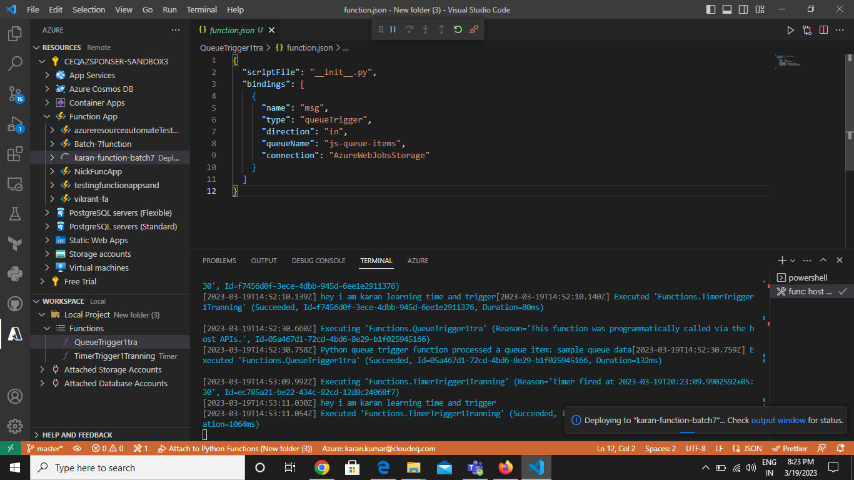

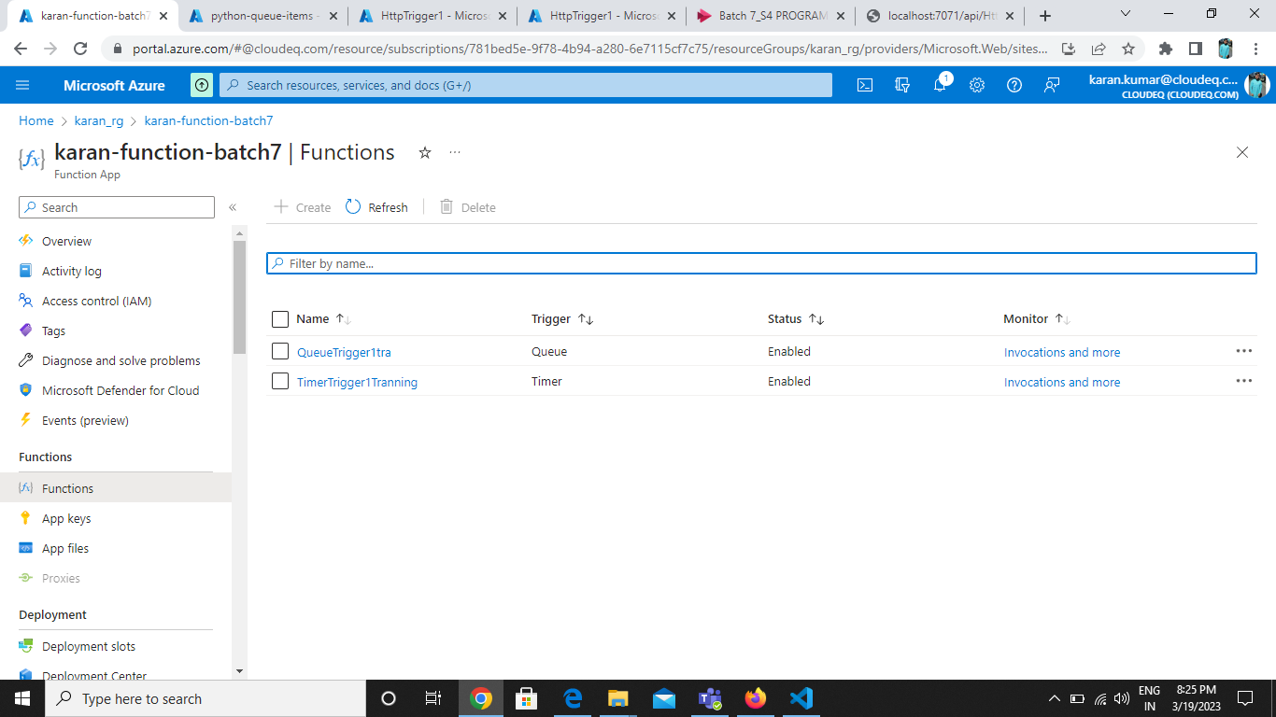

Now Add The Message:

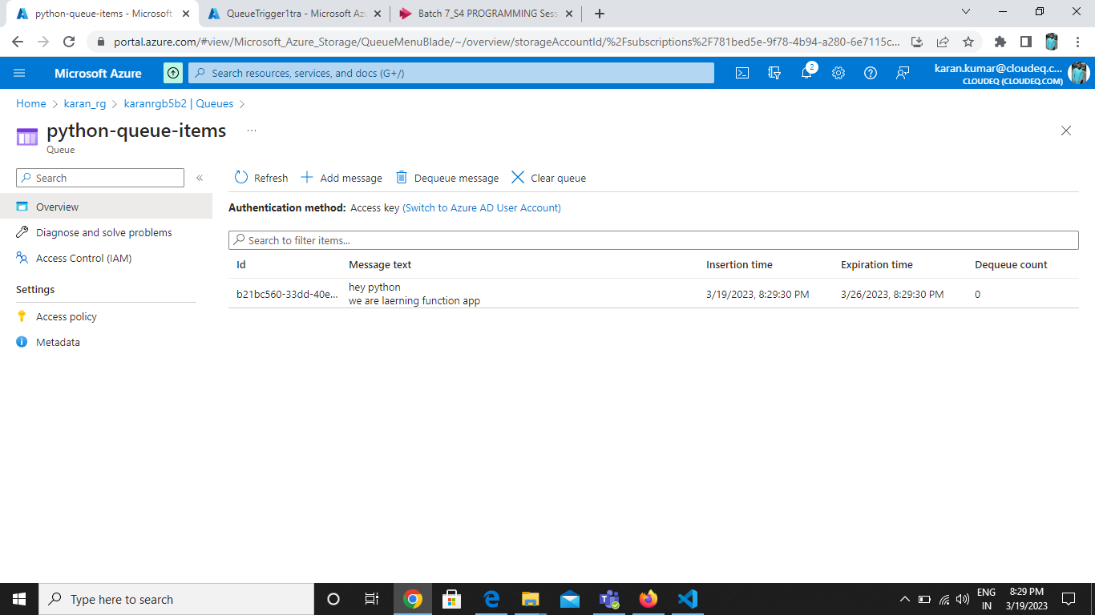

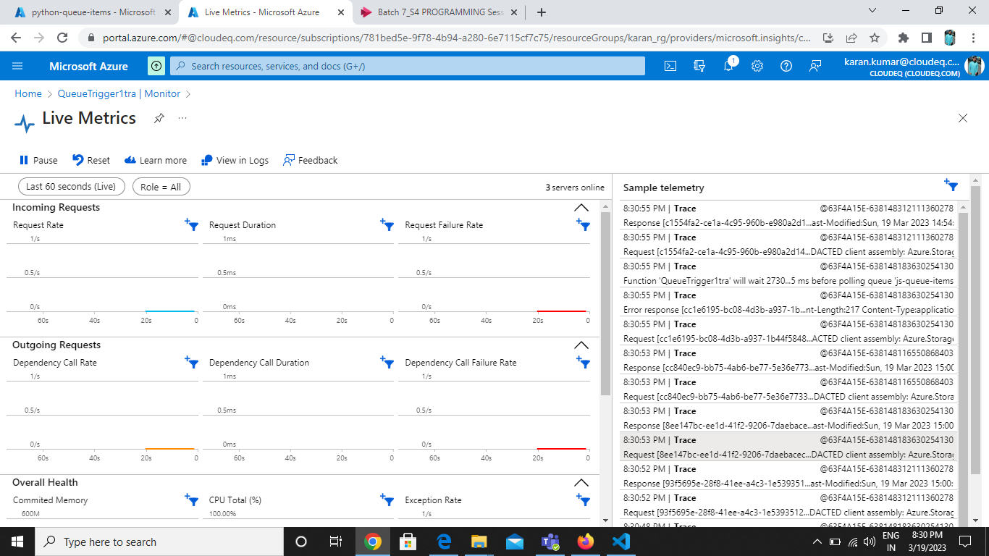

As the message is added the function is triggered. We can see the function logs below.

